Decision Revision Quiz

Answer all questions on a separate sheet recording your answers on both sides. Half will be handed in to check the correct answers.

Section 1: Picture round

Q1. What is the name of this type of graph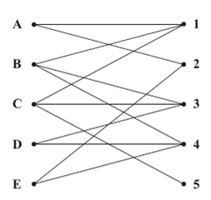 | Q2. What is the name of this type of chart?  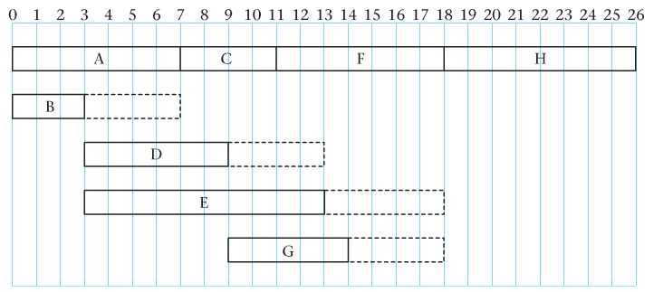
Q3. What does the top box on an activity network represent?  Q4 What is the name for the dashed lines.  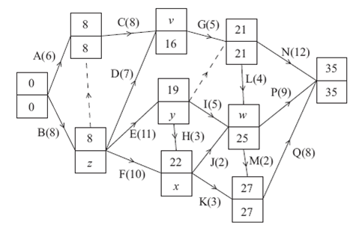 |  | Q5. Which algorithm is being used in the following picture?  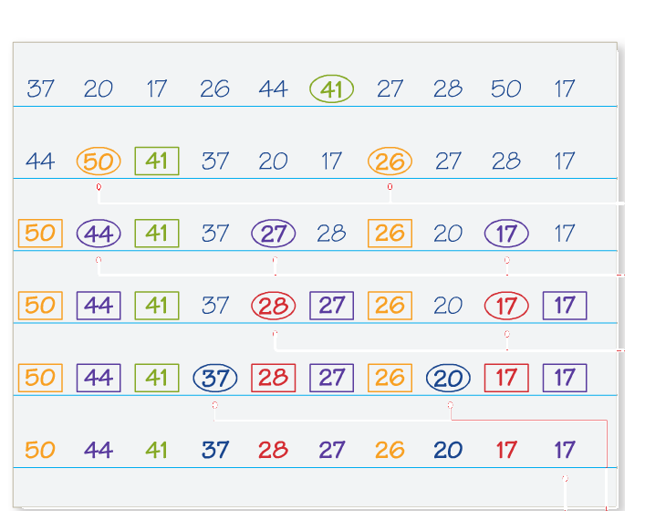

Section 2: Multiple choice
Q1. When would you use a bin-packing algorithm?
- To sort a group into alphabetical order
- To work out how many pieces of wood you needed for a building project
- To find the cheapest way of getting from Sheffield to Edinburgh by bus
- To allocate jobs to five people

Q2. Which of the following is true of Djikstra’s algorithm?
- Point are labelled in order from left to right
- Points can be labelled in any order
- Points are labelled in order according to their distance from the start
- Points are labelled in order of the weight of arcs leading to them

Q3. How would you begin to solve a route inspection problem?
- By finding a Hamiltonian cycle.
- By following a labelling procedure
- By finding earliest and latest times
- By identifying the odd nodes and finding shortest pairs

Q4. In critical path analysis the lower bound for the number of workers needed may be found by
- Dividing number of tasks by minimum time
- Multiplying number of tasks by minimum time
- Dividing total time by minimum time
- Multiplying total time by minimum time

Q5. To find the maximum profit on a graph
- Look for the last point in the region parallel to a profit line
- Look for the first point in the region parallel to a profit line
- Look for the last point in the region perpendicular to a profit line
- Look for the first point in the region perpendicular to a profit line

Section 3: Definitions
The last letter of each answer is the first letter of the next answer.
Q1. A method of finding the minimum spanning tree that can also be applied to a matrix.
Q2. A subgraph which includes all vertices and is also a tree
Q3. A graph that is traversable is known as…
Q4. Another word for a vertex is a …
Q4. Another word for arc is…

Section 4: Quick calculations
Q1. Find an alternating path between D and 1 in picture 1.
Q2. Which activities must be taking place at 12.30 on the chart in picture 3?
Q3. Find w on picture 2.
Q4, 10 lengths of fabric need to be cut from rolls of length 60m. Calculate the lower bound for the number of rolls needed?
Q5. Longley haulage has to transport 1600 packages. Large vans (x) can take 200 packages each, small vans can take 80 each. Write down an inequality, in terms of x and y, to model this constraint.

Team name Team name

Section 1: Picture round Section 1: Picture round
1  2  3  4  5 |  | 1  2  3  4  5

Section 2: Multiple choice Section 2: Multiple choice
1  2  3  4  5 |  | 1  2  3  4  5

Section 3: Definitions Section 3: Definitions
1  2  3  4  5 |  | 1  2  3  4  5

Section 4: Quick calculations Section 4: Quick calculations
1  2  3  4  5 |  | 1  2  3  4  5

