Y13 A level Mathematics
40 Force and Motion 1.5 weeks

Teaching objectives

a Understand and use Newton’s second law for motion in a straight line; extended to situations where forces need to be resolved.
b Understand and use Newton’s third law; equilibrium of forces on a particle and motion in a straight line; application to problems involving smooth pulleys and connected particles; resolving forces in 2D; equilibrium of a particle under coplanar forces.
c Understand and use addition of forces; resultant forces; dynamics for motion in a plane.

Pre-requisite knowledge:

- Basic trig for resolving forces
- Linear and simultaneous equations from GCSE

Resources for advance preparation:

- The ‘Newton’s Laws Experiments’ (which can be found at http://integralmaths.org/sow-resources.php) is an excellent resource to encourage students to experience and visualise scenarios based around force and motion. It gives the opportunity to confront and deal with some of the misconceptions they hold and also provokes discussion about the modelling that is involved.
- Pulley investigations lesson 4
- Mechanics in Action - https://www.stem.org.uk/resources/collection/2943/mechanics-action-project contains lots of useful experiments and discussion of misconceptions
- Powerpoint and questions - https://haringeymath.wordpress.com/mechanics-1/ 1.2 Vectors, 1.4 Dynamics for Newton’s laws of motion including lifts, 1.5 Dynamics for pulleys and towing.

- Vectors questions - https://www.tes.com/teachingresources/hub/secondary/mathematics/advanced-mechanics/vectors
- Newton’s Laws of Motion questions - https://www.tes.com/teaching-resources/hub/secondary/mathematics/advanced-mechanics/newtons-laws-of-motion
- https://www.tes.com/teaching-resource/ocr-mechanics-2-m2-revision-big-exam-style-questions-powerpoint-11205087
- Lots of mechanics resource links - http://www.resourceaholic.com/p/mechanics.html

- Questions by topic - https://www.physicsandmathstutor.com/maths-revision/a-level-mechanics-1/
- https://www.physicsandmathstutor.com/maths-revision/a-level-mechanics-2/

 | Starter | Main teaching  Including key questions, key teaching points, models and resources | Notes  Including Support and Extension | Consolidation/Plenary  Including key questions and homework
1 | Recap drawing force diagrams (from unit 20 AS). | N2L - motion in a straight line including situations where forces need to be resolved.  Integral ‘Newton’s Laws experiments) - Experiment 1: Sliding an object along the floor - involves students using constant acceleration equations to calculate  the deceleration caused by a resistive force  Integral ‘Newton’s Laws experiments) – Experiment 2: Verifying Newton’s Second Law - involves observing connected particles over  a pulley and verifying Newton’s Second law.  Be able to formulate the equation of motion for a particle moving in a straight line or in a plane.  Including motion under gravity. 𝐅_{res}=𝑚𝐚 where F is the resultant force.  Investigating force with bathroom scales and a broom page 61 https://www.stem.org.uk/system/files/elibrary-resources/legacy_files_migrated/3635-Mechanics%20in%20action.pdf | Diagrams need to be really clear especially which forces act where.  Trig confusion will be a barrier for some here.  Use F_{res} instead of F in F=ma for total forces to eliminate the confusion with F in F ≤ μR. | Homework: This ‘Resolving forces Exam Question’ file (link can be found at www.mei.org.uk/integrating-technology) is designed to develop a standard exam question (OCR M1 Jan 2007 Qn 4 which involves resolving forces of magnitude 20N and 16N inclined at 60°) to prompt further discussion and encourage students to ask additional questions. Discussion can be starter for the next lesson.
2 | Discussion and questions from the ‘Resolving forces Exam Question’ homework. | N3L - resolving forces in 2D and equilibrium of a particle under coplanar forces.  https://undergroundmathematics.org/vector-geometry/make-it-equal - In each situation below, three forces are acting on a particle. Given two of the forces and the fact the particle is in equilibrium, find the third force.  https://undergroundmathematics.org/vector-geometry/make-it-stop - Work out the single extra constant force that can be added to this system, so that the particle would be brought instantaneously to rest at the specified time. | Resolve forces in different directions, eg horizontal/vertical for horizontal motion or motion on a plane, parallel to a plane/perpendicular to the plane, and show that the results are the same. Identify the most sensible directions for resolution in different circumstances, or good alternatives. An important skill is to be able to learn to choose directions which simplify working.  Know that a body is in equilibrium under a set of concurrent forces if and only if their resultant is zero.  Be able to formulate and solve equations for a particle in equilibrium: by resolving forces in suitable directions; by drawing and using a polygon of forces eg a triangle of forces. | Homework: Questions from Haringey Maths or other similar
 | Starter | Main teaching  Including key questions, key teaching points, models and resources | Notes  Including Support and Extension | Consolidation/Plenary  Including key questions and homework
3 |  | Resultant forces including using vectors | Know that vectors representing a set of forces in equilibrium sum to zero. Know that a closed figure may be drawn to represent the addition of the forces on an object in equilibrium. | Homework: possible sources for questions above
4 |  | Pulley applications – smooth pulley - vertical motion over a pulley, and on the corner of a table which may be a plane at an angle to the horizontal.  Experiment: Investigate the relationship between the two masses and the resulting acceleration.  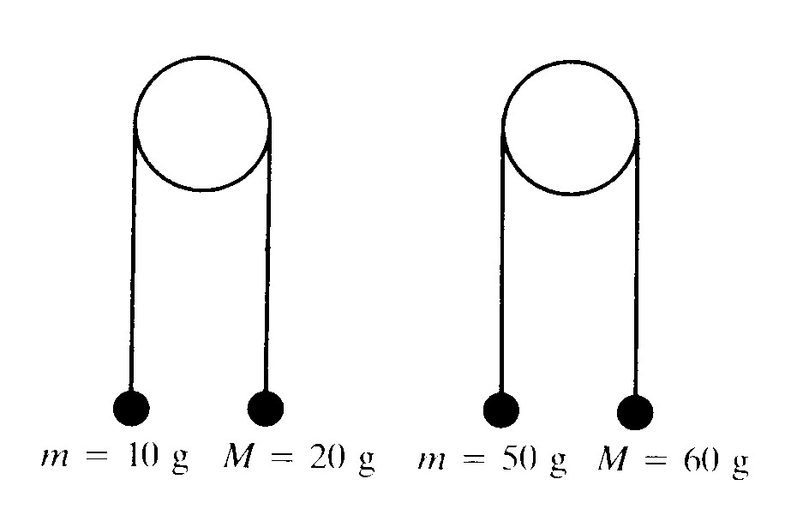  Include an example where the weights are the same and at different heights – this should show up misconceptions. | It is bad practice to consider the separate particles which are not on a straight line as connected and treated as a whole system – the particles should have separate equations of motion.  Include finding the angle of and the resultant force on the pulley. | Homework: Travel up and down in a lift and feel the different on your feet effects when the lift is ascending/descending/accelerating/decelerating.
5 |  | Connected particles applications - car and trailer, train and trucks, lifts – systems can be grouped together and treated as connected particles, or as individual particle particles. | Misconceptions – the difference between tension and thrust, explicitly teach thrust. | Homework: potential sources of questions listed above
6 |  | N2L – motion on a plane – extend to problems where a force may be at an angle to the plane |  | Homework: potential sources of questions listed above

