Y12 AS Mathematics
Unit 3: Quadratic Functions 1.5 weeks

Teaching objectives

a To review knowledge of factorising Quadratics.
b To review knowledge on how to use the quadratic formula
c To review knowledge on how to complete the square
d To gain fluency and develop problem solving skills in the context of modelling with quadratics.
e To be fluent in the f(x) notation when working with functions
f To be able to sketch the graph and find the turning points of a quadratic function
g To be able to find and interpret the Discriminant of a quadratic function
h To gain fluency and develop problem solving skills in the context of the Discriminant

Resources for advance preparation:

UM Proving the Quadratic formula – 1 set of cards between 2
UM - Quadratic Solving Sorter – 1 set of cards between 2
UM Discriminating – 1 set of cards between 2

 | Starter | Main teaching  Including key questions, key teaching points, models and resources | Notes  Including Support and Extension | Consolidation/Plenary  Including key questions and homework
1 | UM - Quadratic Solving Sorter In pairs (Extended starter)  MH Quadratics in disguise | Factorising and Solving Quadratics  How might you go about solving each question?  Students demonstrate their solutions (any student from any pair must be ready to demonstrate their working for any of the groupings).  Factorising and Solving Quadratics to include formula and completing the square.  What is mean by a root? UM Quadratic Grids  If necessary, help them to refine their methods so they have clear strategies for the quadratic formula and completing the square.++  NF Completing the square activity | Pupils will have seen this before but may need reminded.  Pupils can add their own equations and offer equations that do not fit in any category.  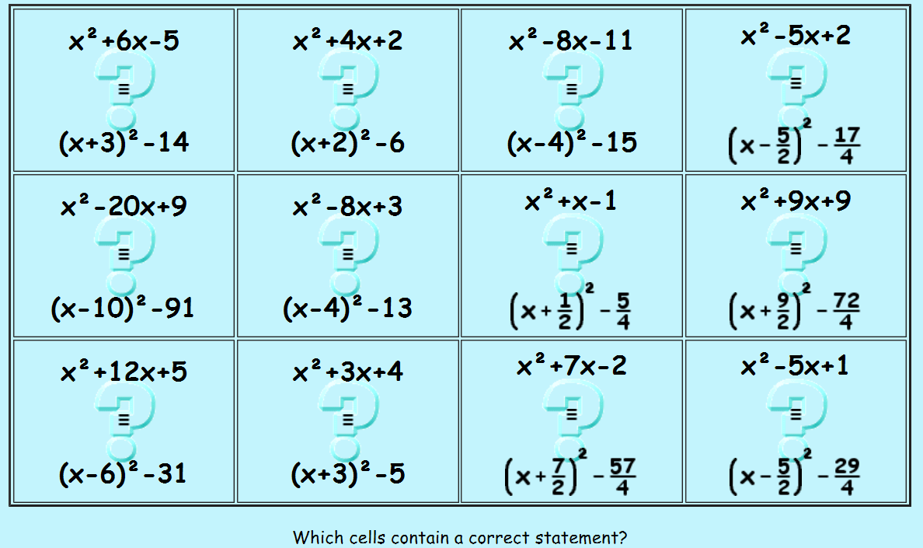  UM one root is double the other Extension problem with quite a simple solution  UM Powerful Quadratics | Are there some equations which belong to more than one group?  UM Factorisable Quadratics  Homework:  nRich - How old am I?  CW Quadratic Discs  Routine practise from old resources or text book or
 | Starter | Main teaching  Including key questions, key teaching points, models and resources | Notes  Including Support and Extension | Consolidation/Plenary  Including key questions and homework
2 | UM When are the coefficients equal to the roots? | Solving Quadratics and Proof  UM Proving the Quadratic formula Lead students through the proof with structure if necessary. | Is there a different way to order the cards and still have a convincing argument?  Can use a structured sheet where fill in the blanks to make it more accessible. | Reflect upon:  How could you prove the result using slightly different steps?  Summarise 3 learning points from the two most recent lessons.  Homework:  SRW Quadratic formula activity  Routine practise from old resources or Integral section 1 level 1 exercise
3 & 4 | RISP 17 Six Parabolas working on computers or with graphical calculator  MEI Quadratic two way table  SU Quadratic Sort | Sketching and Turning Points  What are the key features of a quadratic? Which questions gave you a lot of information? Did you make the most of the information you were given? Could you have avoided asking any of your questions?  UM Which Quadratic? in groups of 4 working in two pairs  UM Geogebra Constructions students will need to have access to Geogebra app or Geogebra on a computer  UM Name that graph  UM Which Parabola | Students could challenge each other by giving their own examples of quadratics, including some where the equations are not in completed square form.  Students should think carefully about the advantages of the different forms of the equations.  Students could use Desmos to check their solutions.  Which of these approaches would work best for cubic polynomials? Explain your thinking. Can any of these approaches be generalised for other polynomials? | RISP 37 Parabolic Clues Use a diagram to help with this one  Homework:  Integral Mystery quadratic?  SRW Sketching Quadratics  Routine practise from old resources or Integral section 1 level 2 exercise
 | Starter | Main teaching  Including key questions, key teaching points, models and resources | Notes  Including Support and Extension | Consolidation/Plenary  Including key questions and homework
5 | RISP 10 More Venn Diagrams working in pairs or small groups  OM Largest result | Discriminant Analysis  UM Discriminating  What strategies have you used?  If you used algebra, could you have used a graph? If you used a graph, could you have used algebra?  Were any cards surprising?  What features of quadratics have you not used to solve this problem?  Could you make up a further card for each of ‘MUST’, ‘MAY’ and ‘CAN’T’?  What can you do well in this topic? | Students add extra cards to Discriminating to try to challenge each other. They should include a written solution for each card they produce. | TM Shape of Quadratic from Discriminant  Homework:  SW Discriminant exam questions  Routine practise from old resources or Integral section 2 level 1 exercise
6 | UM Parabolic Mirrors interesting real life example to begin modelling | Modelling  UM Two Points on the Axis Geogebra required for this task.  DY/Dan Will it hit the hoop? Requires tablets or computers for each pupil 40-50 minute task with real world application | Use GeoGebra to plot some familiar quadratics in different forms and compare these graphs to the graphs in the questions. | Reflect on which situations would a quadratic model be suitable?  Homework:  Routine practise from old resources or Integral section 2 level 2 exercise

