Y13 A level Mathematics
43 Friction 1 week

Teaching objectives

a Understand and use the F ≤ μR model for friction
b coefficient of friction
c motion of a body on a rough surface
d limiting friction and statics.

Pre-requisite knowledge

- Newton’s Laws of Motion
- Resolving forces
- GCSE trigonometry

Resources for advance preparation:

- Mechanics in Action or Integral ‘Law of friction’ experiment

- Underground Maths A Frictional story

Some good detailed powerpoints - https://haringeymath.wordpress.com/mechanics-1/ 1.5 Dynamics and 1.6 Statics
https://haringeymath.wordpress.com/mechanics-2/ 2.6 Statics of rigid bodies
Powerpoint of past exam questions by topic - https://www.tes.com/teaching-resource/ocr-mechanics-2-m2-revision-big-exam-style-questions-powerpoint-11205087
Lots of mechanics resource links - http://www.resourceaholic.com/p/mechanics.html
Questions by topic - https://www.physicsandmathstutor.com/maths-revision/a-level-mechanics-1/
https://www.physicsandmathstutor.com/maths-revision/a-level-mechanics-2/

 | Starter | Main teaching  Including key questions, key teaching points, models and resources | Notes  Including Support and Extension | Consolidation/Plenary  Including key questions and homework
1 | Press the hands together gently. With a small reaction force the book can easily be pulled down as there is little friction.  Press the hands together as hard as possible. With a large reaction force the book cannot easily be pulled down as there is a lot of friction. | What is friction? Coefficient of friction.  Consider different surfaces and compare the coefficients of friction.  Examples of where friction is important: a ladder leaning against a wall would always slide if there were no friction between the foot of the ladder and the ground; the absence of friction in icy conditions causes difficulties for road users.  Experiment: find a room with a lino or tiled floor. Push someone else along with shoes on and then do the same in socks.  Introduce F ≤ μR emphasising the ≤  Use practical examples of motion only occurring when friction is overcome.  The ‘Law of friction experiment’ provides an excellent way to establish the inequality F ≤ μR as a model for friction. This is based on an experiment ‘Law of friction’ in Mechanics in Action.  If forces, including friction, are in static equilibrium, it may be that friction is not limiting and so F = μR would be wrong and lead to error.  Use F_{max} = μR to emphasise the point. | Students need to get the idea of limiting friction and motion occurring only when limiting friction has been exceeded.  Another potential error is to assume that the normal reaction remains unaltered when a force in a system is changed, and consequently that the limiting frictional force remains unaltered. | Homework: selection of questions from the resources listed above.

 | Starter | Main teaching  Including key questions, key teaching points, models and resources | Notes  Including Support and Extension | Consolidation/Plenary  Including key questions and homework
2 |  | Motion of a body on a rough horizontal surface.  If forces, including friction, are in static equilibrium, it may be that friction is not limiting and so F = μR would be wrong and lead to error.  ‘Forces acting on a box’ is an interactive resource (which can be found at www.mei.org.uk/integrating-technology) designed to explore a model for friction.  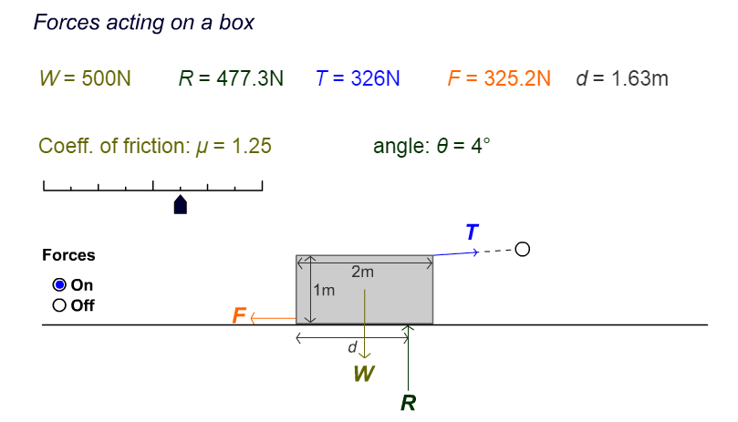  Questions to ask students:  - What do you notice as you change the angle ?  - Under what circumstances does the block move? | Watch for confusion between F for friction and F in Newton’s second law F=ma. A good idea is to use F_{res} to indicate resultant force in the latter. | Homework: selection of questions from the resources listed above.
 | Starter | Main teaching  Including key questions, key teaching points, models and resources | Notes  Including Support and Extension | Consolidation/Plenary  Including key questions and homework
3 | How fast are these particles sliding when they pass? is a question consolidating the previous lesson on horizontal motion. | Motion of a body on a rough plane.  A Frictional story This resource explores the classic situation of a particle on a slope. Students have to draw diagrams and resolve forces, but are also provided with an opportunity to think about how friction varies when a particle is not moving and why the variation is linear. Students will be reminded that the frictional force acting on a particle is modelled by Fr≤μR, which should help them avoid the misconception that Fr=μR at all times. | Watch for confusion between F for friction and F in Newton’s second law F=ma. A good idea is to use Fres to indicate resultant force in the latter. | Homework: Review question How are these connected particles held on a slope?
4 |  | Statics eg ladder problems  Powerpoint and questions from Haringey |  | Homework: more questions from Haringey or selection of questions from the resources listed above.

