Y13 A-level Mathematics
33 Vectors 0.5 weeks

Teaching objectives

a Use vectors in two dimensions and three dimensions
b Calculate the magnitude and direction of a vector and convert between component form and magnitude/direction form.
c Add vectors diagrammatically and perform the algebraic operations of vector addition and multiplication by scalars, and understand their geometrical interpretations.
d Understand and use position vectors; calculate the distance between two points represented by position vectors
e Use vectors to solve problems in pure mathematics and in context, including forces and kinematics.

Resources for advance preparation:

 | Starter | Main teaching  Including key questions, key teaching points, models and resources | Notes  Including Support and Extension | Consolidation/Plenary  Including key questions and homework
1 & 2 | Mini-whiteboard: Quick review questions about 2d vectors (magnitude, direction, addition, subtraction etc) | MEI: Properties of 3D vectors  (to develop fluency with vectors and working in 3d)  Visualising 3d vectors https://www.geogebra.org/m/VHQzeMX9  Key Question  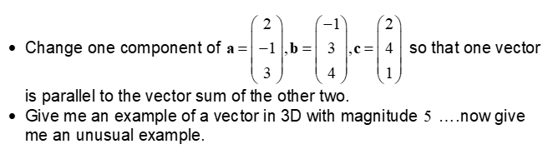  Key Question:  UM: Vector geometry question  Link to Mechanics (and parametrics)  UM: One Windy Day  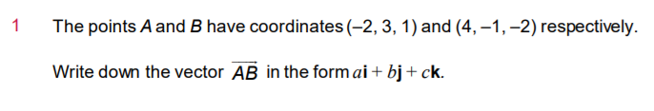  (from AQA teaching guidance) | This should be a review of AS content but now in 3 dimensions. May only need to be one lesson but combined with other resources from forces & kinematics.  Students need to become familiar with both column vectors and i,j,k notation, where i,j, and k are unit vectors in mutually perpendicular directions in a right-handed coordinate system. (AQA teaching guidance)  Take care with notation.  Support: Use the resources in 2D.  Extension:  UM: Vector Geometry 3 lines | Topic test (integral)  Solomon worksheet  Solutions

